OFBiz Ecommerce

1. Created Product Category as NEW_ARRIVAL

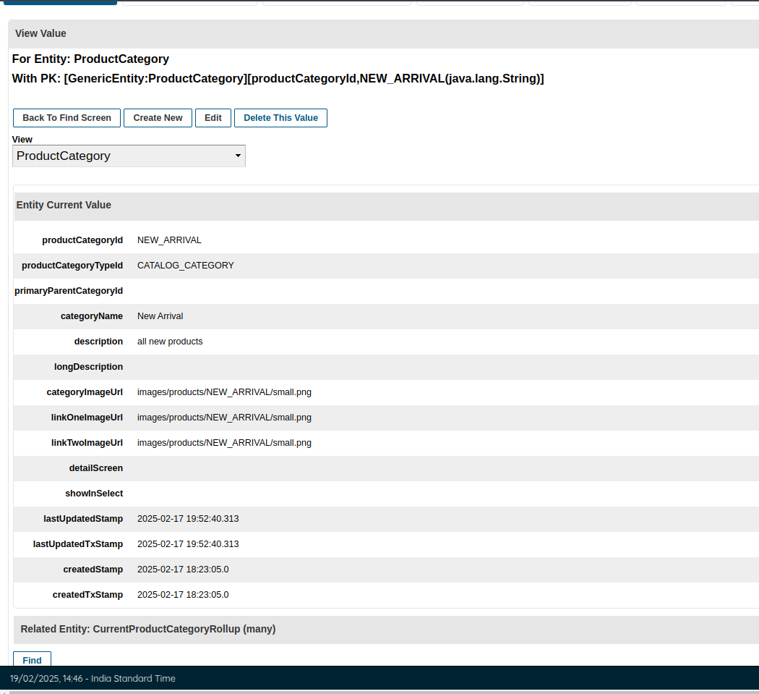

1. Created Sub Category as ELECTRONICS

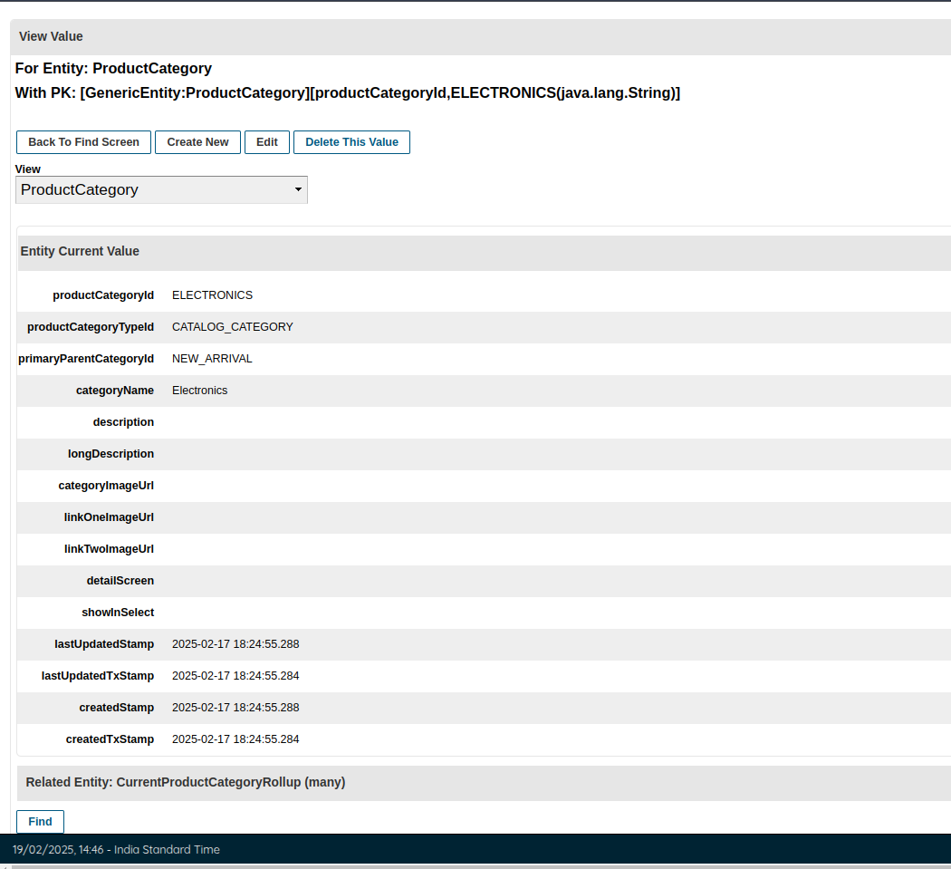

1. Product - ELE101, FrontLoaded Washing Machine  
   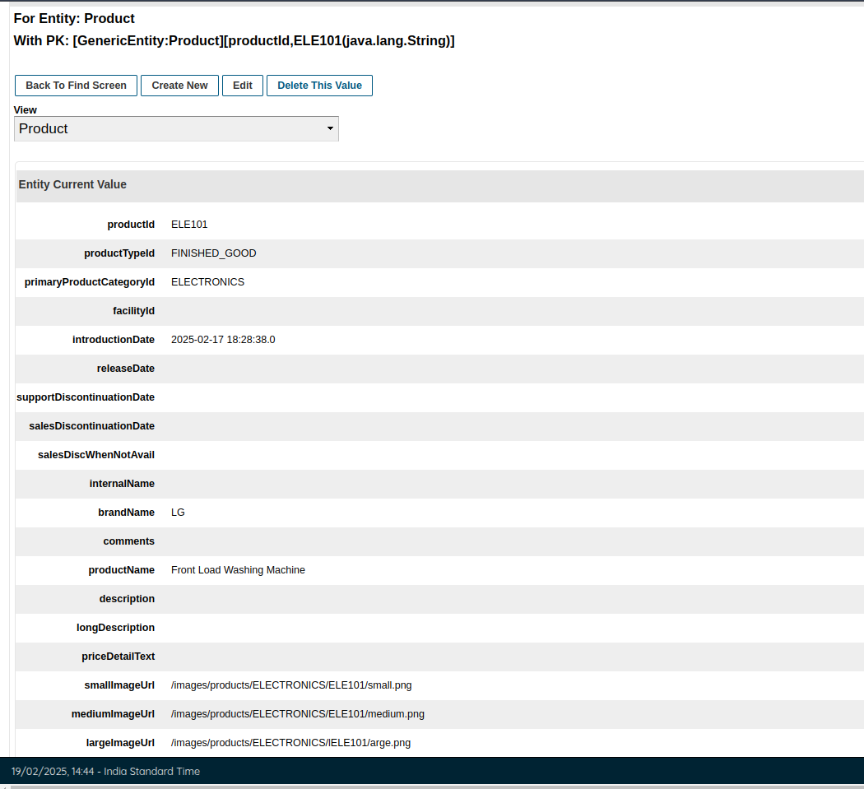
2. Added Default Price in ProductPrice entity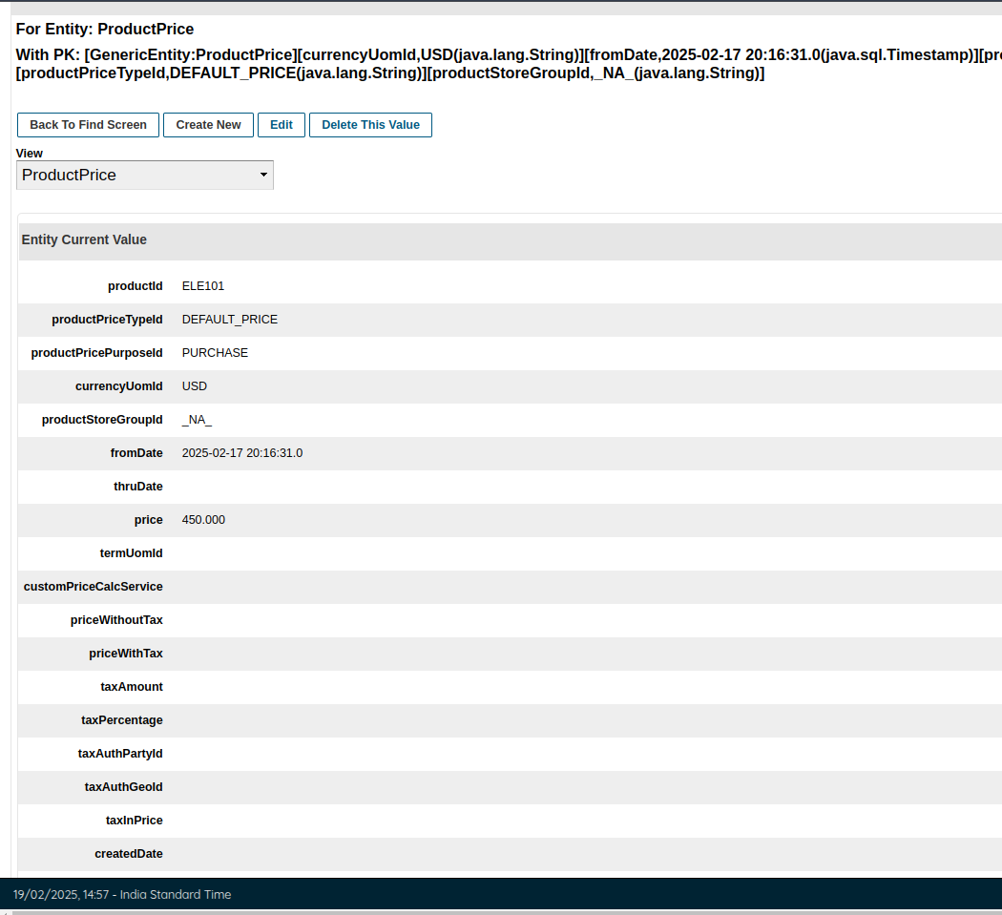
3. Added List Price to it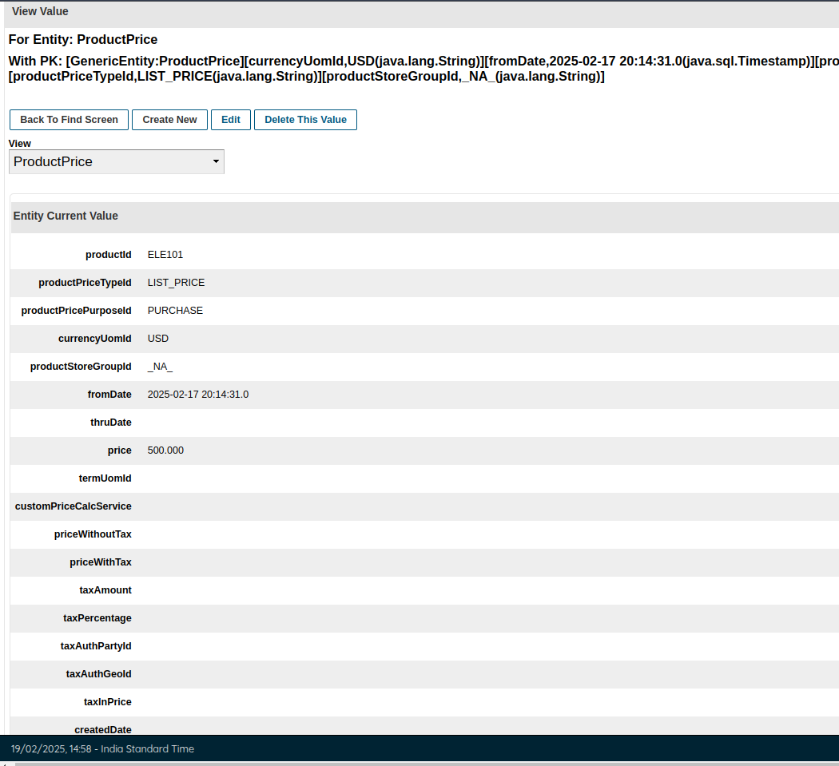
4. Created Category Rollup for Parent- NEW_ARRIVAL and Child ELECTRONICS  
   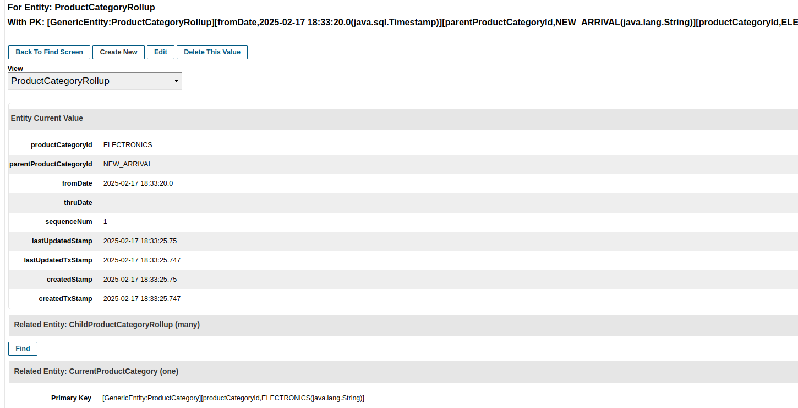

7. Added Product to the category in Product Category Member  
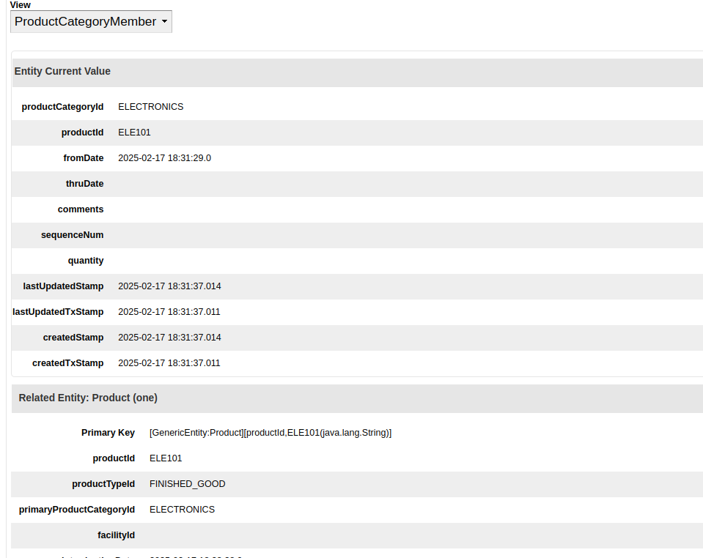

8. Created ProdCatalog as NEW_CATALOG, CatalogName- New Arrivals  
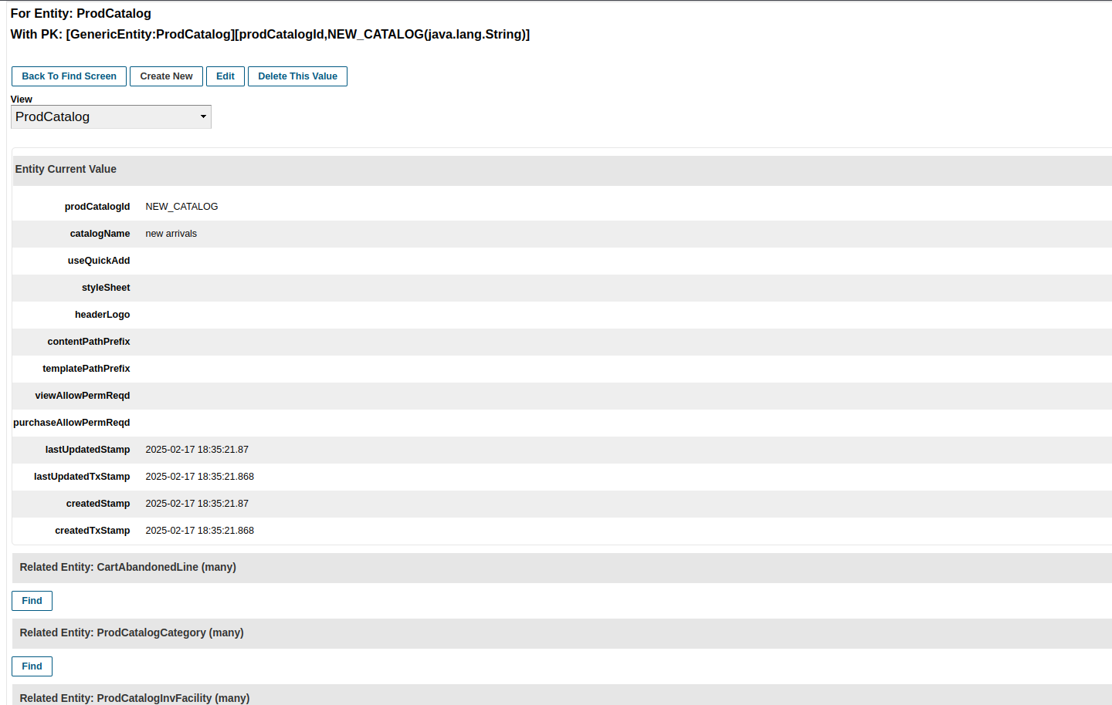

9. Added this Catalog to the BrowseRootCatalogCategory  
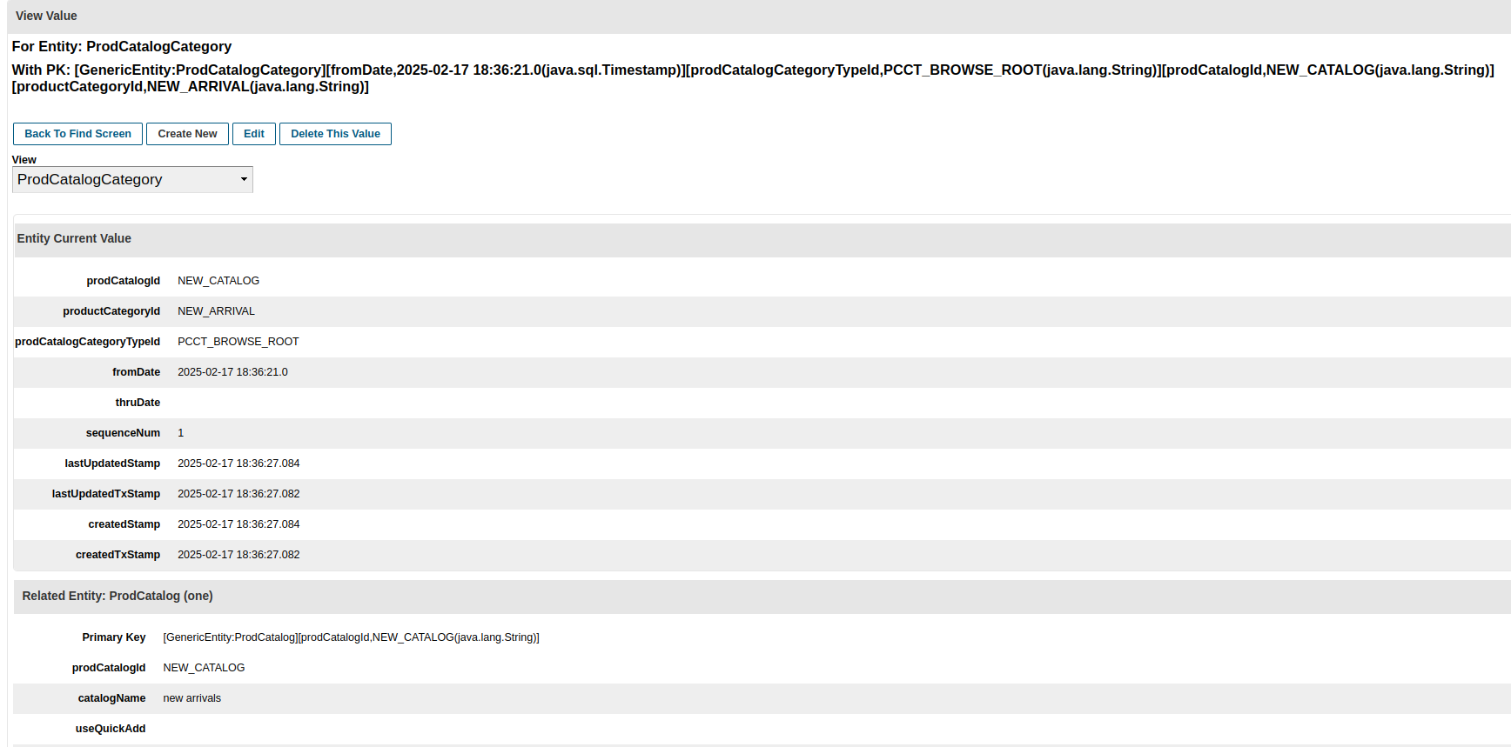

10. Added the same catalog to Search Allow Category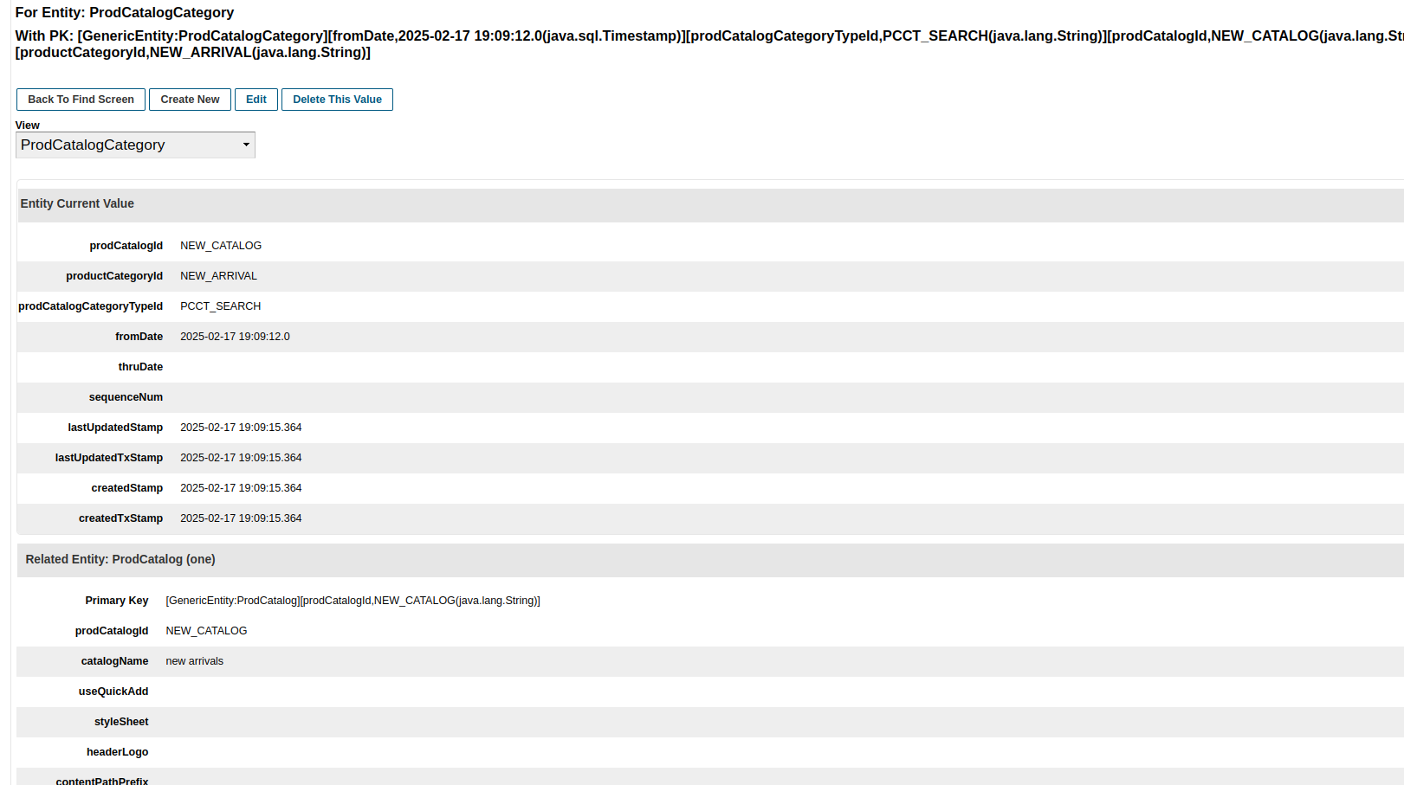

11. Added this Catalog to an existing Product Store 9000, via ProductStoreCatalog entity  


Ecommerce Website-

1. Selected Catalog as New Arrival (Catalog Name) & Category as ELECTRONICS (CategoryID)

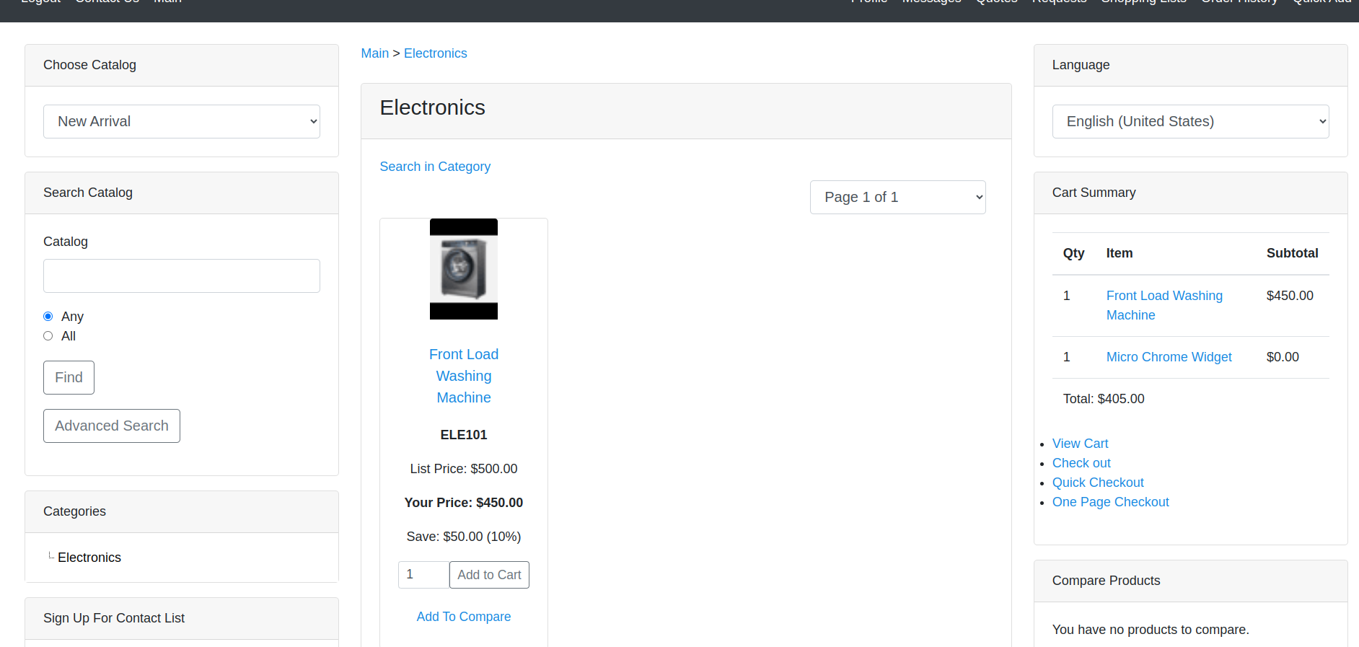

1. Product ELE101 added to cart  
   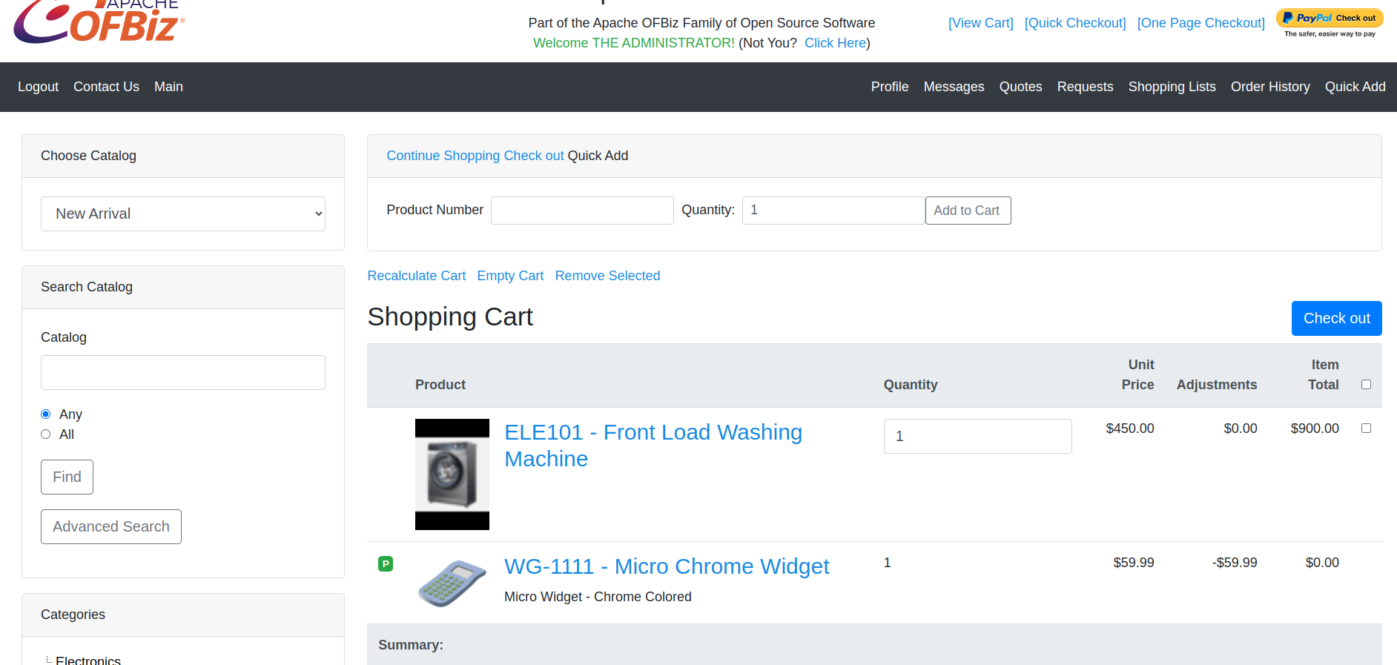
2. Asking Shipping Location when clicked on checkout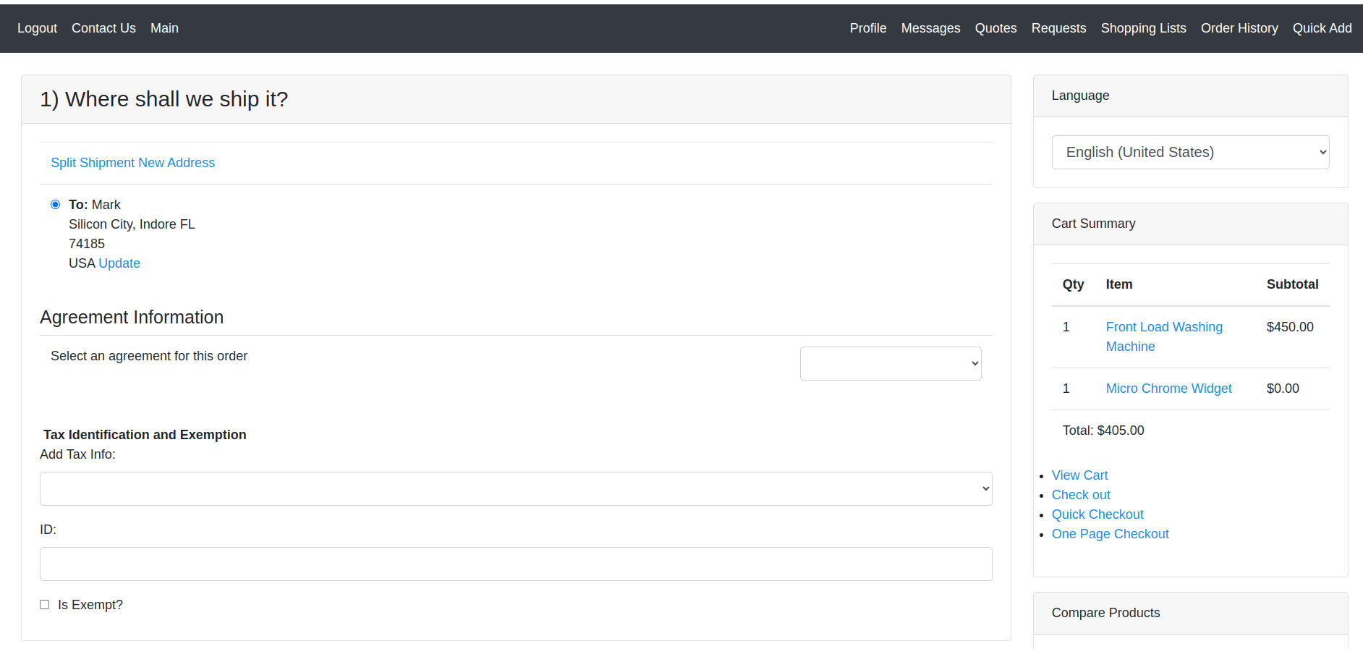
3. Selecting Courier Service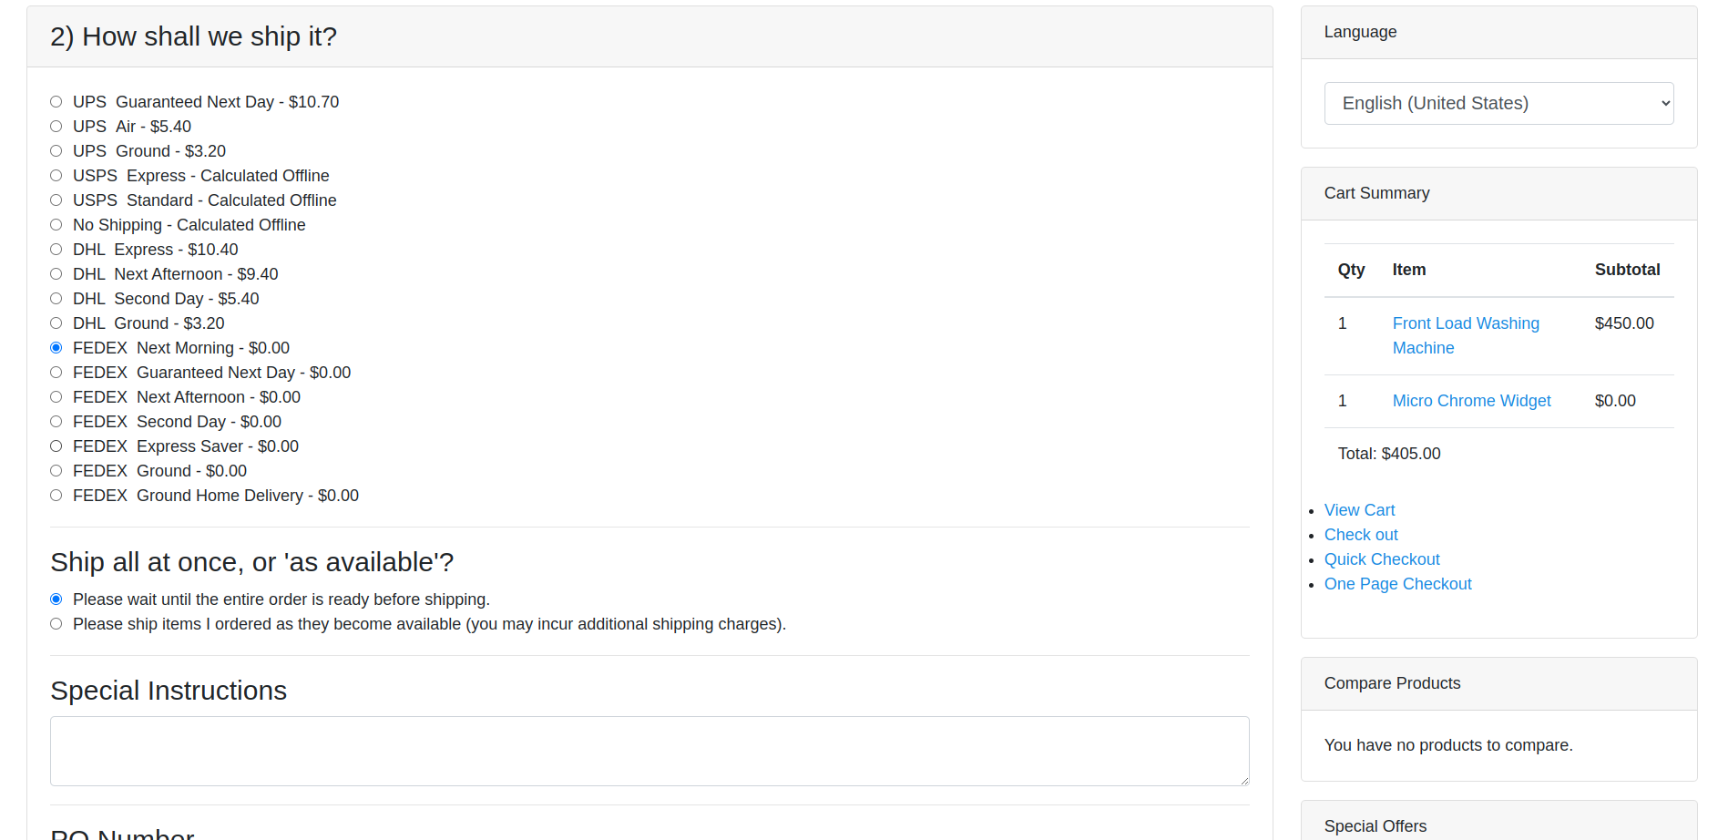
4. Asking for Payment Preference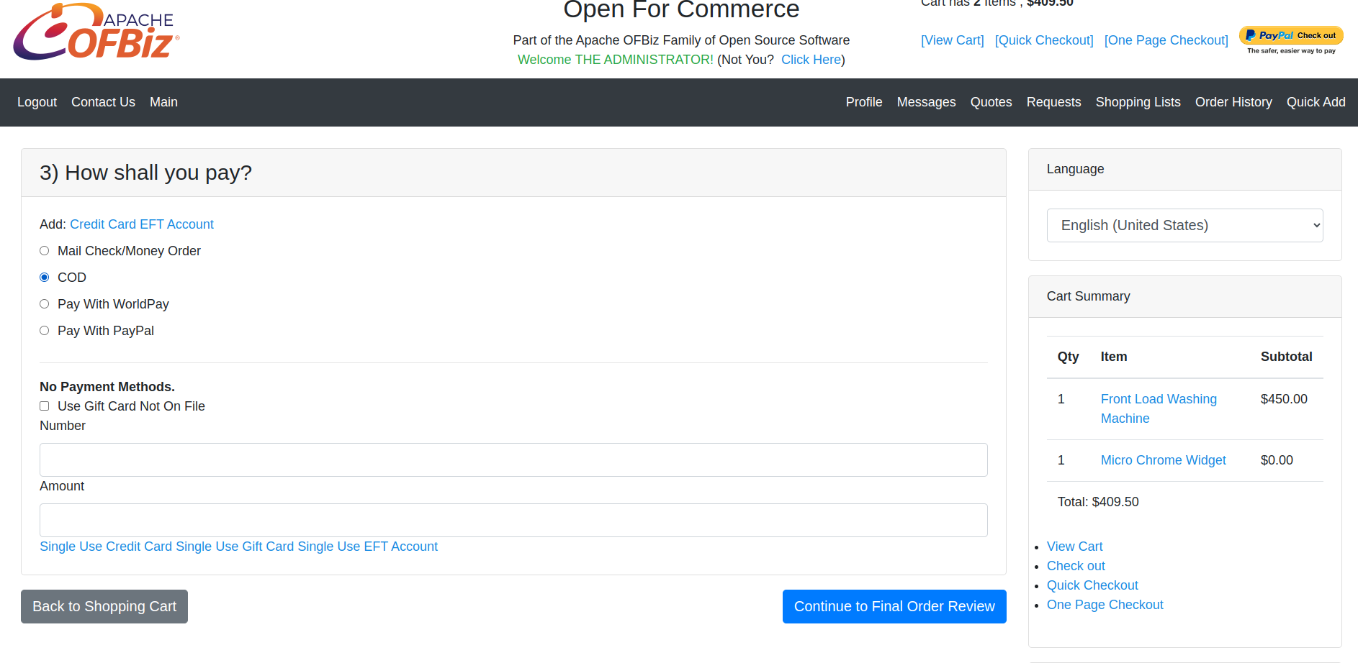
5. Final Checkout Page  
   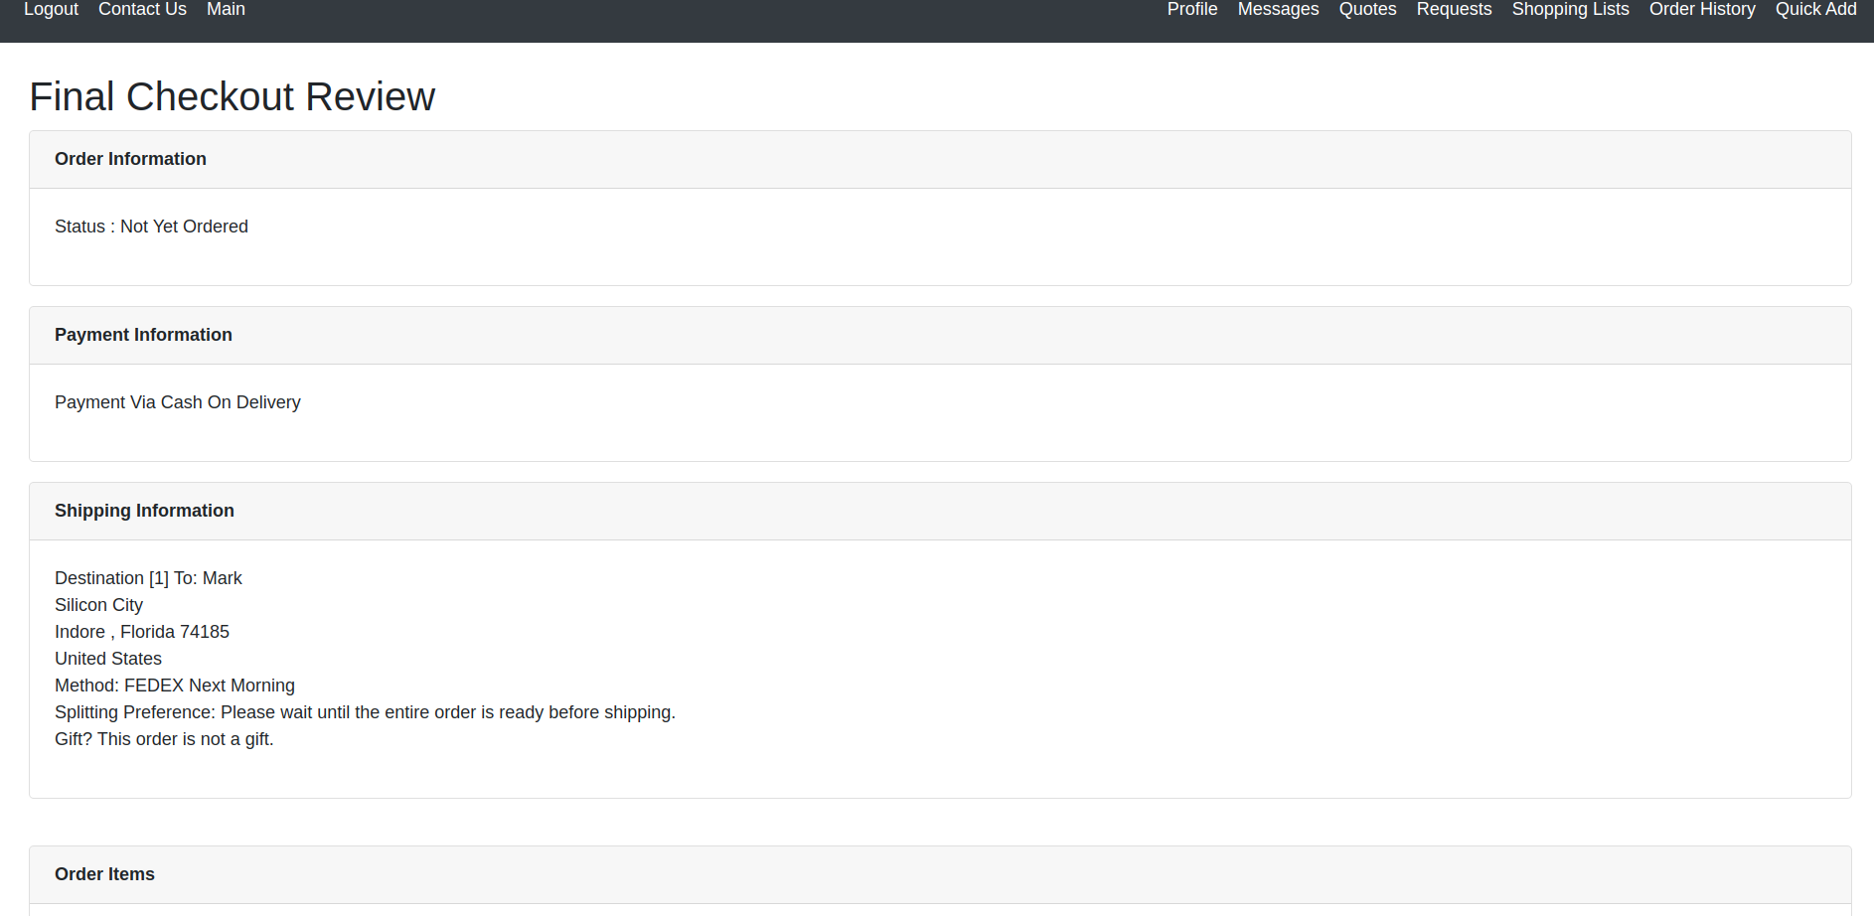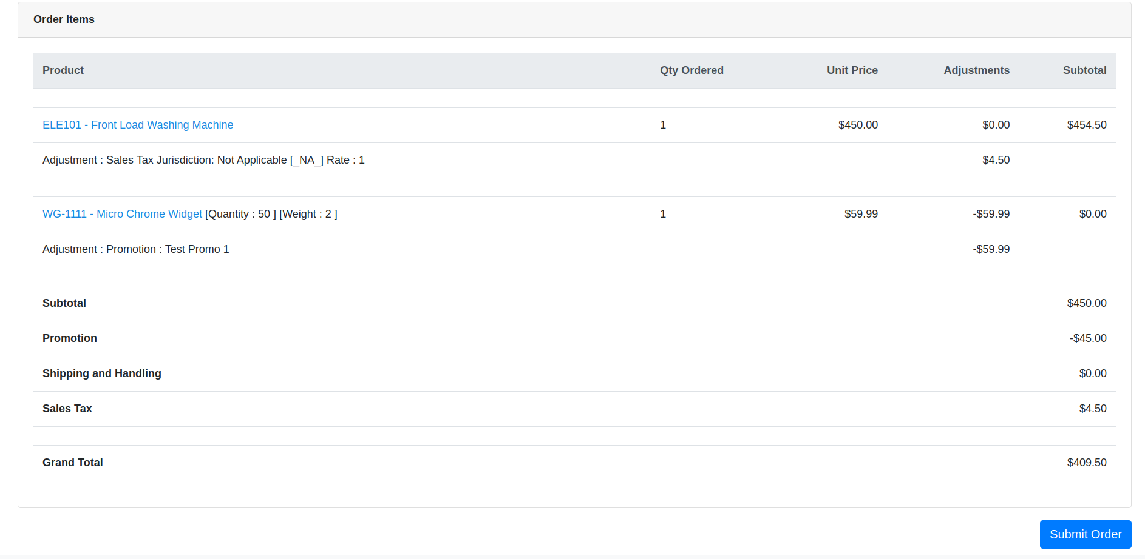
6. Order Confirmation Page  
   